Position Description Words
# Source: AI Source: Provided by: [Data Path: Persons Table -> ID Column: 1, Name_En Column: Motasem Essam] -> From: [ChatGPT] on [7/17/2026]
Spatial Position is the description of where an object is located relative to another object, a reference point, or a coordinate system. Unlike measurements such as length or mass, spatial position often uses descriptive words (qualitative descriptions) or coordinates (quantitative descriptions) to specify location.
Position description words are essential in geometry, geography, navigation, engineering, robotics, architecture, computer graphics, and everyday communication.

Definition
# Source: AI Source: Provided by: [Data Path: Persons Table -> ID Column: 1, Name_En Column: Motasem Essam] -> From: [ChatGPT] on [7/17/2026]
Spatial Position is the description of an object's location, orientation, or relative placement with respect to another object or reference frame.

Purpose
# Source: AI Source: Provided by: [Data Path: Persons Table -> ID Column: 1, Name_En Column: Motasem Essam] -> From: [ChatGPT] on [7/17/2026]
Spatial position descriptions are used to:
- Describe object locations.
- Give directions.
- Explain relative positions.
- Navigate environments.
- Design layouts.
- Communicate spatial relationships.
- Support mapping and surveying.

Position Description Words

Horizontal Position
# Source: AI Source: Provided by: [Data Path: Persons Table -> ID Column: 1, Name_En Column: Motasem Essam] -> From: [ChatGPT] on [7/17/2026]
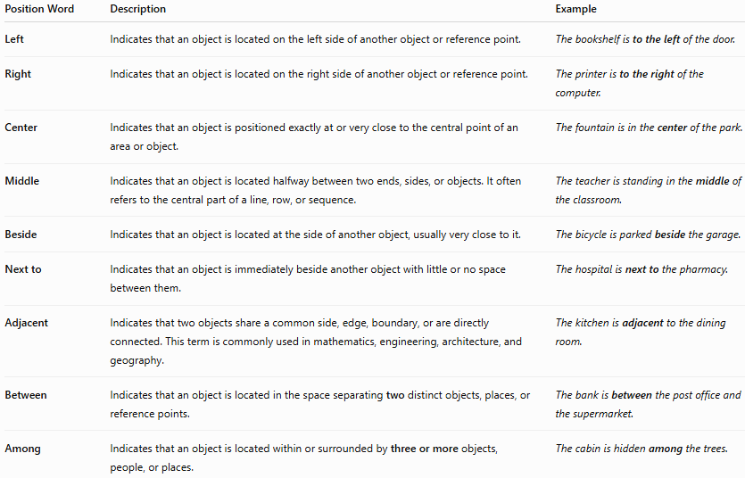
Position Word | Description | Example
Left | Indicates that an object is located on the left side of another object or reference point. | The bookshelf is to the left of the door.
Right | Indicates that an object is located on the right side of another object or reference point. | The printer is to the right of the computer.
Center | Indicates that an object is positioned exactly at or very close to the central point of an area or object. | The fountain is in the center of the park.
Middle | Indicates that an object is located halfway between two ends, sides, or objects. It often refers to the central part of a line, row, or sequence. | The teacher is standing in the middle of the classroom.
Beside | Indicates that an object is located at the side of another object, usually very close to it. | The bicycle is parked beside the garage.
Next to | Indicates that an object is immediately beside another object with little or no space between them. | The hospital is next to the pharmacy.
Adjacent | Indicates that two objects share a common side, edge, boundary, or are directly connected. This term is commonly used in mathematics, engineering, architecture, and geography. | The kitchen is adjacent to the dining room.
Between | Indicates that an object is located in the space separating two distinct objects, places, or reference points. | The bank is between the post office and the supermarket.
Among | Indicates that an object is located within or surrounded by three or more objects, people, or places. | The cabin is hidden among the trees.

Notes
- Center and Middle are similar, but center usually refers to the exact central point, while middle often refers to the central region or halfway position.
- Beside and Next to are very similar; next to typically implies immediate proximity with almost no gap.
- Adjacent is more formal and often implies that two objects touch or share a boundary.
- Between is used for two reference objects.
- Among is used for three or more reference objects.

Vertical Position
# Source: AI Source: Provided by: [Data Path: Persons Table -> ID Column: 1, Name_En Column: Motasem Essam] -> From: [ChatGPT] on [7/17/2026]
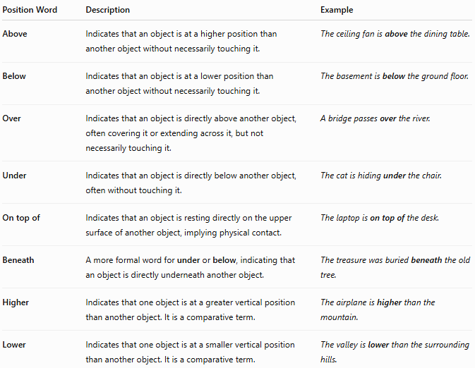
Position Word | Description | Example
Above | Indicates that an object is at a higher position than another object without necessarily touching it. | The ceiling fan is above the dining table.
Below | Indicates that an object is at a lower position than another object without necessarily touching it. | The basement is below the ground floor.
Over | Indicates that an object is directly above another object, often covering it or extending across it, but not necessarily touching it. | A bridge passes over the river.
Under | Indicates that an object is directly below another object, often without touching it. | The cat is hiding under the chair.
On top of | Indicates that an object is resting directly on the upper surface of another object, implying physical contact. | The laptop is on top of the desk.
Beneath | A more formal word for under or below, indicating that an object is directly underneath another object. | The treasure was buried beneath the old tree.
Higher | Indicates that one object is at a greater vertical position than another object. It is a comparative term. | The airplane is higher than the mountain.
Lower | Indicates that one object is at a smaller vertical position than another object. It is a comparative term. | The valley is lower than the surrounding hills.
Notes
- Above and Below describe relative vertical position and do not imply contact.
- Over and Under usually describe objects that are vertically aligned; contact is not required.
- On top of always implies physical contact.
- Beneath is more formal than under and is common in literature and formal writing.
- Higher and Lower are comparative words, used to compare the vertical positions of two or more objects.

Front–Back Position
# Source: AI Source: Provided by: [Data Path: Persons Table -> ID Column: 1, Name_En Column: Motasem Essam] -> From: [ChatGPT] on [7/17/2026]
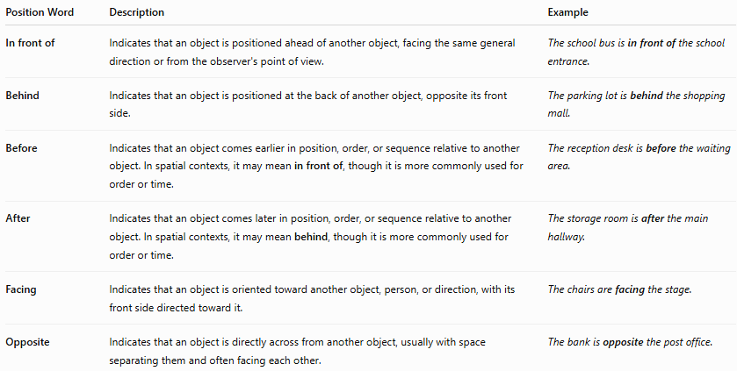
Position Word | Description | Example
In front of | Indicates that an object is positioned ahead of another object, facing the same general direction or from the observer's point of view. | The school bus is in front of the school entrance.
Behind | Indicates that an object is positioned at the back of another object, opposite its front side. | The parking lot is behind the shopping mall.
Before | Indicates that an object comes earlier in position, order, or sequence relative to another object. In spatial contexts, it may mean in front of, though it is more commonly used for order or time. | The reception desk is before the waiting area.
After | Indicates that an object comes later in position, order, or sequence relative to another object. In spatial contexts, it may mean behind, though it is more commonly used for order or time. | The storage room is after the main hallway.
Facing | Indicates that an object is oriented toward another object, person, or direction, with its front side directed toward it. | The chairs are facing the stage.
Opposite | Indicates that an object is directly across from another object, usually with space separating them and often facing each other. | The bank is opposite the post office.

Notes
- In front of and Behind describe relative position.
- Facing describes orientation, not necessarily location. Two objects can be facing each other while remaining far apart.
- Opposite usually means directly across from another object and often implies they face one another.
- Before and After are primarily used for time or sequence, but they can also describe position or order in formal contexts. For everyday spatial descriptions, in front of and behind are generally preferred.

Inside–Outside Position
# Source: AI Source: Provided by: [Data Path: Persons Table -> ID Column: 1, Name_En Column: Motasem Essam] -> From: [ChatGPT] on [7/17/2026]
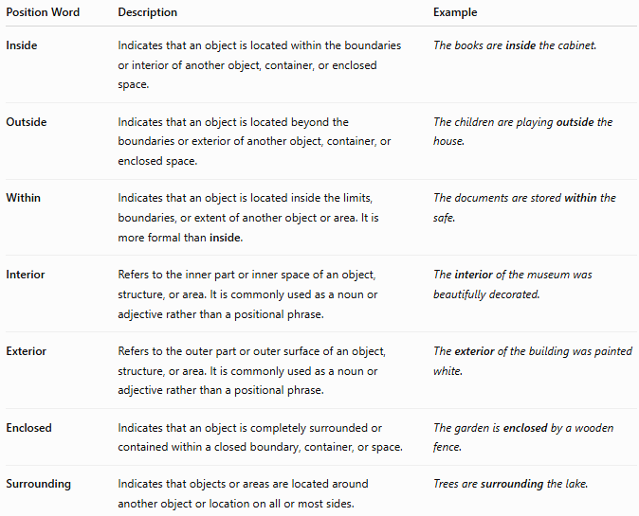
Position Word | Description | Example
Inside | Indicates that an object is located within the boundaries or interior of another object, container, or enclosed space. | The books are inside the cabinet.
Outside | Indicates that an object is located beyond the boundaries or exterior of another object, container, or enclosed space. | The children are playing outside the house.
Within | Indicates that an object is located inside the limits, boundaries, or extent of another object or area. It is more formal than inside. | The documents are stored within the safe.
Interior | Refers to the inner part or inner space of an object, structure, or area. It is commonly used as a noun or adjective rather than a positional phrase. | The interior of the museum was beautifully decorated.
Exterior | Refers to the outer part or outer surface of an object, structure, or area. It is commonly used as a noun or adjective rather than a positional phrase. | The exterior of the building was painted white.
Enclosed | Indicates that an object is completely surrounded or contained within a closed boundary, container, or space. | The garden is enclosed by a wooden fence.
Surrounding | Indicates that objects or areas are located around another object or location on all or most sides. | Trees are surrounding the lake.
Notes
- Inside and Outside are direct opposites and are the most common everyday position words.
- Within is a more formal alternative to inside, often used in technical, scientific, or legal writing.
- Interior and Exterior describe the inner and outer parts of an object or structure rather than the relative position of another object.
- Enclosed emphasizes that something is fully contained or surrounded by a boundary.
- Surrounding indicates that objects are located around another object, usually on multiple sides, but does not necessarily imply that they completely enclose it.

Distance Position
# Source: AI Source: Provided by: [Data Path: Persons Table -> ID Column: 1, Name_En Column: Motasem Essam] -> From: [ChatGPT] on [7/17/2026]
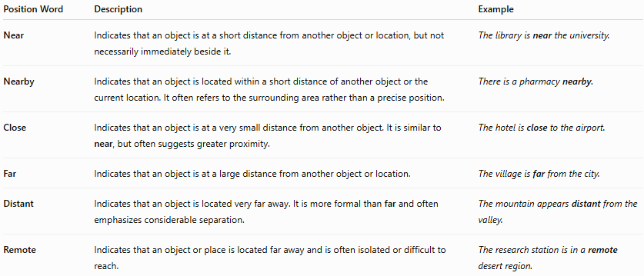
Position Word | Description | Example
Near | Indicates that an object is at a short distance from another object or location, but not necessarily immediately beside it. | The library is near the university.
Nearby | Indicates that an object is located within a short distance of another object or the current location. It often refers to the surrounding area rather than a precise position. | There is a pharmacy nearby.
Close | Indicates that an object is at a very small distance from another object. It is similar to near, but often suggests greater proximity. | The hotel is close to the airport.
Far | Indicates that an object is at a large distance from another object or location. | The village is far from the city.
Distant | Indicates that an object is located very far away. It is more formal than far and often emphasizes considerable separation. | The mountain appears distant from the valley.
Remote | Indicates that an object or place is located far away and is often isolated or difficult to reach. | The research station is in a remote desert region.

Notes
- Near and Close are very similar, but close usually implies a smaller distance than near.
- Nearby often functions as an adverb ("The store is nearby.") but can also be used as an adjective ("a nearby restaurant").
- Far is the direct opposite of near.
- Distant is a more formal way of saying far, often emphasizing a considerable separation.
- Remote not only means far away, but also suggests that the location is isolated, inaccessible, or difficult to reach.

Directional Position
# Source: AI Source: Provided by: [Data Path: Persons Table -> ID Column: 1, Name_En Column: Motasem Essam] -> From: [ChatGPT] on [7/17/2026]
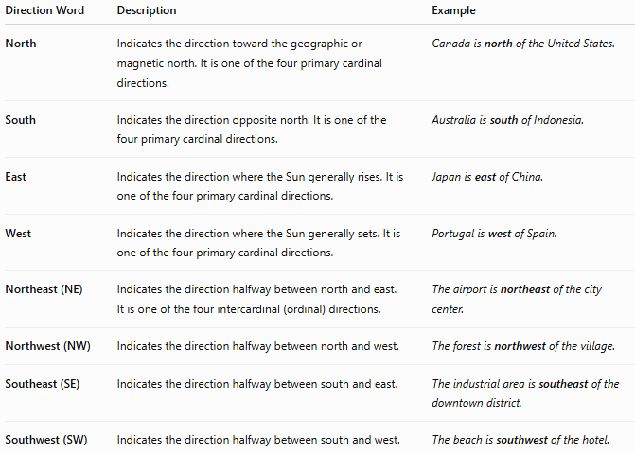
Direction Word | Description | Example
North | Indicates the direction toward the geographic or magnetic north. It is one of the four primary cardinal directions. | Canada is north of the United States.
South | Indicates the direction opposite north. It is one of the four primary cardinal directions. | Australia is south of Indonesia.
East | Indicates the direction where the Sun generally rises. It is one of the four primary cardinal directions. | Japan is east of China.
West | Indicates the direction where the Sun generally sets. It is one of the four primary cardinal directions. | Portugal is west of Spain.
Northeast (NE) | Indicates the direction halfway between north and east. It is one of the four intercardinal (ordinal) directions. | The airport is northeast of the city center.
Northwest (NW) | Indicates the direction halfway between north and west. | The forest is northwest of the village.
Southeast (SE) | Indicates the direction halfway between south and east. | The industrial area is southeast of the downtown district.
Southwest (SW) | Indicates the direction halfway between south and west. | The beach is southwest of the hotel.
Notes
- North, South, East, and West are called the cardinal directions (or cardinal points).
- Northeast, Northwest, Southeast, and Southwest are called the intercardinal directions (or ordinal directions).
- These directions are commonly used in:
  - Geography
  - Navigation
  - Cartography (maps)
  - Surveying
  - Aviation
  - Maritime navigation
  - GPS and mapping systems
- Directions are usually determined using a compass, map, GPS, or geographic coordinate system.
Compass Rose
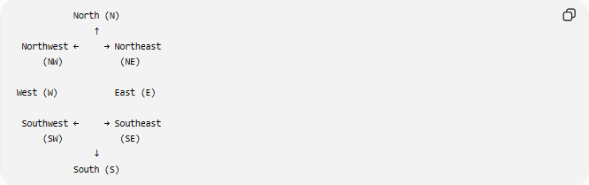
North (N)
↑
Northwest ← → Northeast
(NW) (NE)

West (W) East (E)

Southwest ← → Southeast
(SW) (SE)
↓
South (S)

Relative Position
# Source: AI Source: Provided by: [Data Path: Persons Table -> ID Column: 1, Name_En Column: Motasem Essam] -> From: [ChatGPT] on [7/17/2026]
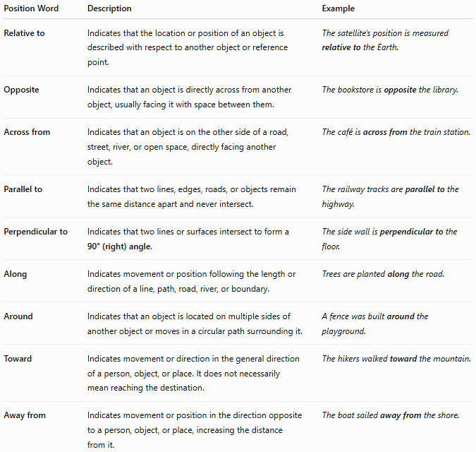
Position Word | Description | Example
Relative to | Indicates that the location or position of an object is described with respect to another object or reference point. | The satellite's position is measured relative to the Earth.
Opposite | Indicates that an object is directly across from another object, usually facing it with space between them. | The bookstore is opposite the library.
Across from | Indicates that an object is on the other side of a road, street, river, or open space, directly facing another object. | The café is across from the train station.
Parallel to | Indicates that two lines, edges, roads, or objects remain the same distance apart and never intersect. | The railway tracks are parallel to the highway.
Perpendicular to | Indicates that two lines or surfaces intersect to form a 90° (right) angle. | The side wall is perpendicular to the floor.
Along | Indicates movement or position following the length or direction of a line, path, road, river, or boundary. | Trees are planted along the road.
Around | Indicates that an object is located on multiple sides of another object or moves in a circular path surrounding it. | A fence was built around the playground.
Toward | Indicates movement or direction in the general direction of a person, object, or place. It does not necessarily mean reaching the destination. | The hikers walked toward the mountain.
Away from | Indicates movement or position in the direction opposite to a person, object, or place, increasing the distance from it. | The boat sailed away from the shore.
Notes
- Relative to introduces the reference object used to describe another object's position.
- Opposite and Across from are similar:
  - Opposite is a general term meaning directly facing.
  - Across from usually implies a road, street, river, or other open space lies between the two objects.
- Parallel to describes objects that never intersect and remain the same distance apart.
- Perpendicular to describes objects that intersect at 90°.
- Along describes position or movement following a path or boundary.
- Around describes surrounding or circular movement.
- Toward and Away from describe direction of movement, not fixed location.

Corner Position
# Source: AI Source: Provided by: [Data Path: Persons Table -> ID Column: 1, Name_En Column: Motasem Essam] -> From: [ChatGPT] on [7/17/2026]
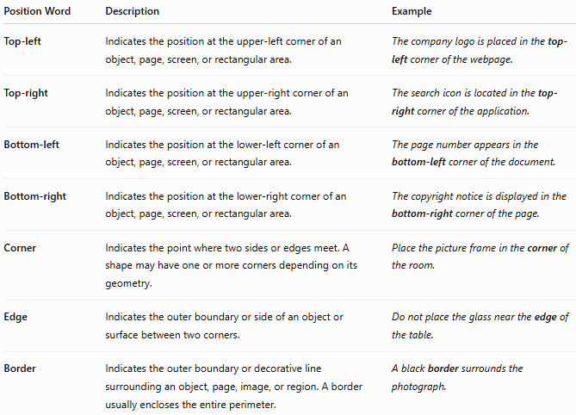
Position Word | Description | Example
Top-left | Indicates the position at the upper-left corner of an object, page, screen, or rectangular area. | The company logo is placed in the top-left corner of the webpage.
Top-right | Indicates the position at the upper-right corner of an object, page, screen, or rectangular area. | The search icon is located in the top-right corner of the application.
Bottom-left | Indicates the position at the lower-left corner of an object, page, screen, or rectangular area. | The page number appears in the bottom-left corner of the document.
Bottom-right | Indicates the position at the lower-right corner of an object, page, screen, or rectangular area. | The copyright notice is displayed in the bottom-right corner of the page.
Corner | Indicates the point where two sides or edges meet. A shape may have one or more corners depending on its geometry. | Place the picture frame in the corner of the room.
Edge | Indicates the outer boundary or side of an object or surface between two corners. | Do not place the glass near the edge of the table.
Border | Indicates the outer boundary or decorative line surrounding an object, page, image, or region. A border usually encloses the entire perimeter. | A black border surrounds the photograph.
Notes
- Top-left, top-right, bottom-left, and bottom-right refer to the four specific corners of a rectangular object, page, screen, or image.
- Corner refers to the point where two edges meet.
- Edge refers to the side or outer limit between corners.
- Border refers to the complete outer boundary surrounding an object or area and often has a decorative or protective purpose.
Illustration
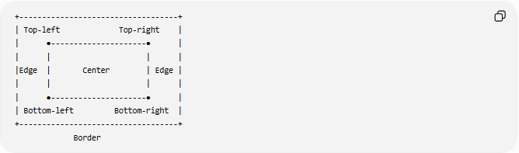
+-----------------------------------+
| Top-left Top-right |
| ●---------------------● |
| | | |
|Edge | Center | Edge |
| | | |
| ●---------------------● |
| Bottom-left Bottom-right |
+-----------------------------------+
Border
Difference between Edge and Border
- Edge → One side or boundary of an object.
- Border → The entire outer boundary surrounding the object.
- Corner → The point where two edges meet.

Central Position
# Source: AI Source: Provided by: [Data Path: Persons Table -> ID Column: 1, Name_En Column: Motasem Essam] -> From: [ChatGPT] on [7/17/2026]
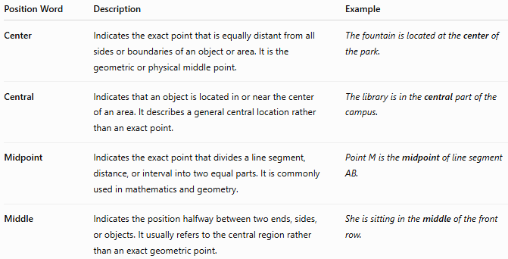
Position Word | Description | Example
Center | Indicates the exact point that is equally distant from all sides or boundaries of an object or area. It is the geometric or physical middle point. | The fountain is located at the center of the park.
Central | Indicates that an object is located in or near the center of an area. It describes a general central location rather than an exact point. | The library is in the central part of the campus.
Midpoint | Indicates the exact point that divides a line segment, distance, or interval into two equal parts. It is commonly used in mathematics and geometry. | Point M is the midpoint of line segment AB.
Middle | Indicates the position halfway between two ends, sides, or objects. It usually refers to the central region rather than an exact geometric point. | She is sitting in the middle of the front row.
Notes
- Center refers to the exact geometric center of an object or region.
- Central describes something located in the center area, but not necessarily at the exact center.
- Midpoint is a precise mathematical term referring to the point that divides a line segment or interval into two equal parts.
- Middle is a general everyday term for the central part or halfway position and is usually less precise than center or midpoint.
Comparison
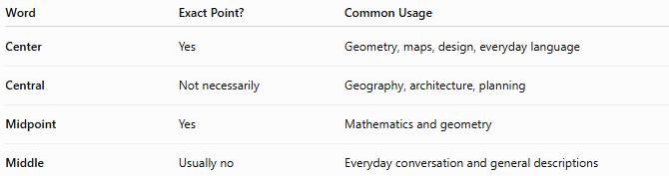
Word | Exact Point? | Common Usage
Center | Yes | Geometry, maps, design, everyday language
Central | Not necessarily | Geography, architecture, planning
Midpoint | Yes | Mathematics and geometry
Middle | Usually no | Everyday conversation and general descriptions
Illustration
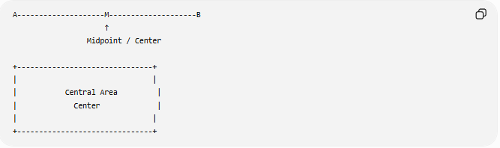
A--------------------M--------------------B
↑
Midpoint / Center

+-------------------------------+
| |
| Central Area |
| Center |
| |
+-------------------------------+
- Midpoint applies primarily to a line segment.
- Center applies to shapes, objects, and regions.
- Central refers to the general middle area.
- Middle refers to the central part in everyday language.

Orientation Words
# Source: AI Source: Provided by: [Data Path: Persons Table -> ID Column: 1, Name_En Column: Motasem Essam] -> From: [ChatGPT] on [7/17/2026]
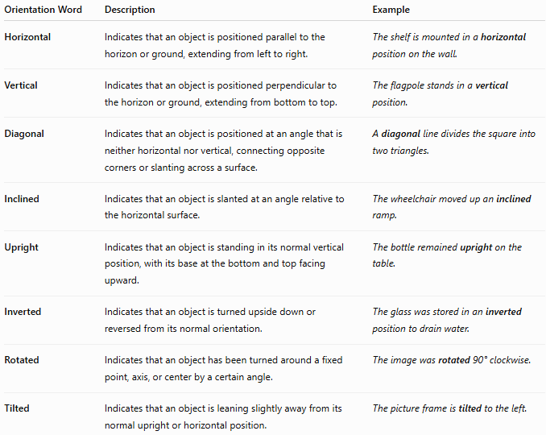
Orientation Word | Description | Example
Horizontal | Indicates that an object is positioned parallel to the horizon or ground, extending from left to right. | The shelf is mounted in a horizontal position on the wall.
Vertical | Indicates that an object is positioned perpendicular to the horizon or ground, extending from bottom to top. | The flagpole stands in a vertical position.
Diagonal | Indicates that an object is positioned at an angle that is neither horizontal nor vertical, connecting opposite corners or slanting across a surface. | A diagonal line divides the square into two triangles.
Inclined | Indicates that an object is slanted at an angle relative to the horizontal surface. | The wheelchair moved up an inclined ramp.
Upright | Indicates that an object is standing in its normal vertical position, with its base at the bottom and top facing upward. | The bottle remained upright on the table.
Inverted | Indicates that an object is turned upside down or reversed from its normal orientation. | The glass was stored in an inverted position to drain water.
Rotated | Indicates that an object has been turned around a fixed point, axis, or center by a certain angle. | The image was rotated 90° clockwise.
Tilted | Indicates that an object is leaning slightly away from its normal upright or horizontal position. | The picture frame is tilted to the left.
Notes
- Horizontal and Vertical are the two primary orientations.
- Diagonal describes an orientation that is between horizontal and vertical, usually forming an oblique line.
- Inclined generally refers to an object that is slanted upward or downward relative to the horizontal, often intentionally (such as a ramp).
- Tilted usually describes a slight lean from the normal position, while inclined may describe any sloped position.
- Upright is the normal standing orientation.
- Inverted is the opposite of upright (upside down).
- Rotated describes turning an object by a specified angle around a center or axis; the object may still be upright, horizontal, or vertical after rotation.
Comparison
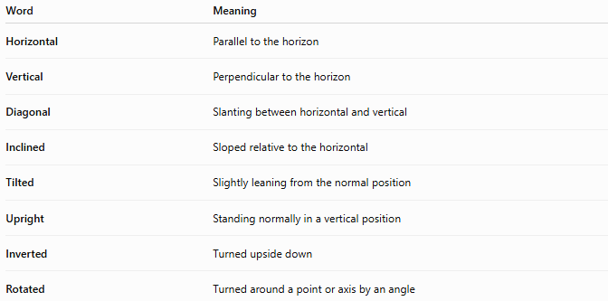
Word | Meaning
Horizontal | Parallel to the horizon
Vertical | Perpendicular to the horizon
Diagonal | Slanting between horizontal and vertical
Inclined | Sloped relative to the horizontal
Tilted | Slightly leaning from the normal position
Upright | Standing normally in a vertical position
Inverted | Turned upside down
Rotated | Turned around a point or axis by an angle

Sequence Position
# Source: AI Source: Provided by: [Data Path: Persons Table -> ID Column: 1, Name_En Column: Motasem Essam] -> From: [ChatGPT] on [7/17/2026]
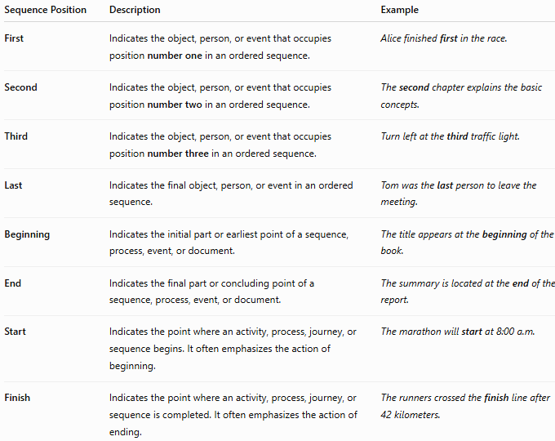
Sequence Position | Description | Example
First | Indicates the object, person, or event that occupies position number one in an ordered sequence. | Alice finished first in the race.
Second | Indicates the object, person, or event that occupies position number two in an ordered sequence. | The second chapter explains the basic concepts.
Third | Indicates the object, person, or event that occupies position number three in an ordered sequence. | Turn left at the third traffic light.
Last | Indicates the final object, person, or event in an ordered sequence. | Tom was the last person to leave the meeting.
Beginning | Indicates the initial part or earliest point of a sequence, process, event, or document. | The title appears at the beginning of the book.
End | Indicates the final part or concluding point of a sequence, process, event, or document. | The summary is located at the end of the report.
Start | Indicates the point where an activity, process, journey, or sequence begins. It often emphasizes the action of beginning. | The marathon will start at 8:00 a.m.
Finish | Indicates the point where an activity, process, journey, or sequence is completed. It often emphasizes the action of ending. | The runners crossed the finish line after 42 kilometers.
Notes
- First, Second, and Third are ordinal position words that indicate the order of items in a sequence.
- Last indicates the final position in a sequence.
- Beginning and End describe the first part and last part of a sequence, document, process, or event.
- Start and Finish usually describe the points where an action begins and ends, rather than simply locations in a sequence.
Comparison
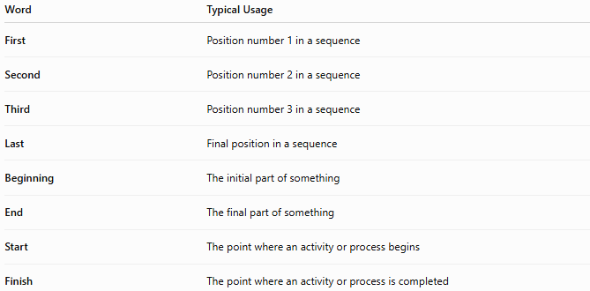
Word | Typical Usage
First | Position number 1 in a sequence
Second | Position number 2 in a sequence
Third | Position number 3 in a sequence
Last | Final position in a sequence
Beginning | The initial part of something
End | The final part of something
Start | The point where an activity or process begins
Finish | The point where an activity or process is completed

Examples
# Source: AI Source: Provided by: [Data Path: Persons Table -> ID Column: 1, Name_En Column: Motasem Essam] -> From: [ChatGPT] on [7/17/2026]
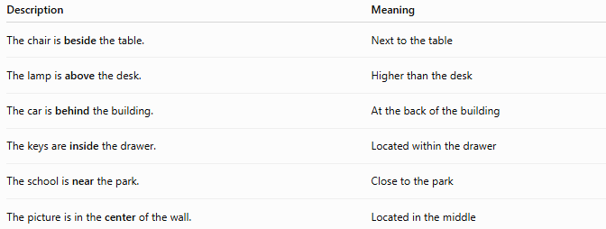
Description | Meaning
The chair is beside the table. | Next to the table
The lamp is above the desk. | Higher than the desk
The car is behind the building. | At the back of the building
The keys are inside the drawer. | Located within the drawer
The school is near the park. | Close to the park
The picture is in the center of the wall. | Located in the middle

Quantitative Position
# Source: AI Source: Provided by: [Data Path: Persons Table -> ID Column: 1, Name_En Column: Motasem Essam] -> From: [ChatGPT] on [7/17/2026]
Spatial position can also be expressed numerically using:
- Coordinates (x, y)
- Coordinates (x, y, z)
- Latitude and longitude
- Distance and direction
- Bearings
- Angles
Examples:
- (4, 6)
- (2, 5, 8)
- 30° North, 31° East

Applications
# Source: AI Source: Provided by: [Data Path: Persons Table -> ID Column: 1, Name_En Column: Motasem Essam] -> From: [ChatGPT] on [7/17/2026]
Spatial position descriptions are used in:
- Geometry
- Geography
- Navigation
- Architecture
- Engineering
- Robotics
- Computer graphics
- Cartography
- GIS
- Everyday communication

Everyday Importance
# Source: AI Source: Provided by: [Data Path: Persons Table -> ID Column: 1, Name_En Column: Motasem Essam] -> From: [ChatGPT] on [7/17/2026]
Spatial position words help us:
- Give directions.
- Describe locations.
- Arrange furniture.
- Read maps.
- Follow GPS navigation.
- Organize objects.
- Understand diagrams.

Common Mistakes
# Source: AI Source: Provided by: [Data Path: Persons Table -> ID Column: 1, Name_En Column: Motasem Essam] -> From: [ChatGPT] on [7/17/2026]
- Confusing left and right.
- Using above instead of over in contexts where contact matters.
- Mixing inside and outside.
- Confusing near with next to.
- Using relative directions without specifying the reference object.

Key Points
# Source: AI Source: Provided by: [Data Path: Persons Table -> ID Column: 1, Name_En Column: Motasem Essam] -> From: [ChatGPT] on [7/17/2026]
- Spatial position describes where an object is located.
- It can be qualitative (using descriptive words) or quantitative (using coordinates or measurements).
- Position words express relationships between objects.
- Coordinates provide precise locations.
- Spatial descriptions are essential in science, engineering, navigation, and daily life.

Spatial Position vs. Direction
# Source: AI Source: Provided by: [Data Path: Persons Table -> ID Column: 1, Name_En Column: Motasem Essam] -> From: [ChatGPT] on [7/17/2026]
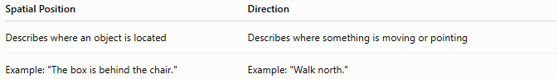
Spatial Position | Direction
Describes where an object is located | Describes where something is moving or pointing
Example: "The box is behind the chair." | Example: "Walk north."

Spatial Position vs. Distance
# Source: AI Source: Provided by: [Data Path: Persons Table -> ID Column: 1, Name_En Column: Motasem Essam] -> From: [ChatGPT] on [7/17/2026]
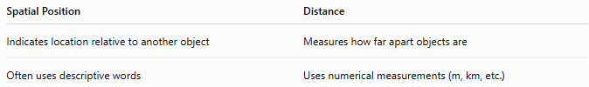
Spatial Position | Distance
Indicates location relative to another object | Measures how far apart objects are
Often uses descriptive words | Uses numerical measurements (m, km, etc.)

Spatial Position vs. Orientation
# Source: AI Source: Provided by: [Data Path: Persons Table -> ID Column: 1, Name_En Column: Motasem Essam] -> From: [ChatGPT] on [7/17/2026]
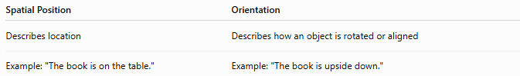
Spatial Position | Orientation
Describes location | Describes how an object is rotated or aligned
Example: "The book is on the table." | Example: "The book is upside down."

Conclusion
# Source: AI Source: Provided by: [Data Path: Persons Table -> ID Column: 1, Name_En Column: Motasem Essam] -> From: [ChatGPT] on [7/17/2026]
Spatial Position describes where an object is located relative to another object, reference point, or coordinate system. It can be expressed qualitatively using words such as above, below, left, right, inside, outside, near, behind, and between, or quantitatively using coordinates, distances, and directions. Spatial position descriptions are fundamental to mathematics, geometry, geography, engineering, navigation, robotics, computer graphics, and everyday communication, enabling accurate description and understanding of the relationships between objects in space.

